**ACTIVITY SUGGESTIONS FOR WORKBOXES & VOCABULARY TO USE**

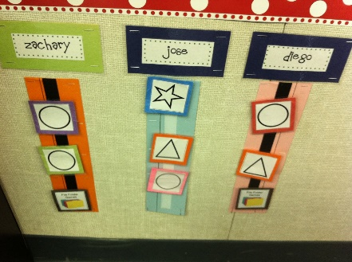[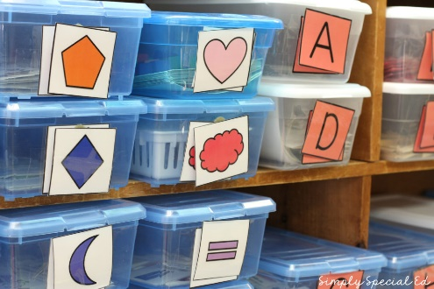](https://www.teacherspayteachers.com/Product/Simply-Special-Task-Box-System-For-Autism-and-Special-Education-Classrooms-2038843)

**TIPS**

* Any activity or worksheet can be placed in your child’s workboxes. The following are some suggestions. Use your discretion or consult with your child’s speech therapist or teacher in determining the appropriateness of each activity for your child.
* Parents should have control over activity items and prompt their child to identify or request each item (Examples: 1. parent holds a ziplock bag with all puzzle pieces and child has the puzzle board, 2. Parent has all shapes in a ziplock bag and child has the shape sorter bucket, 3. Parent has control over bubbles and provides child with bubble wand or blows bubbles for child following request, etc.)
* Do not provide your child with all items- withholding items and showing your child how to request items verbally or through use of a device creates opportunities for communication and practice.
* Repeated practice/use of the same activities/items throughout the week will provide your child with opportunities to practice and improve his/her communication skills. Many children learn well with repeated practice using the same materials. Children tend to pay attention and learn best when learning is fun!! Use of preferred activities may improve your child’s attention to tasks provided.
* Place *highly* preferred items at the end of the schedule/in the final workbox. It may motivate your child to complete other/less preferred activities first!
* If your child communicates verbally- model the following vocabulary suggestions for them to verbally request….or provide your child with the initial sound of the word to (example: /m/ for “mouth” while holding up Mr. Potato Head mouth.) If your child uses a single word spontaneously to request or identify.
* If your child communicates using a speech generating device or iPad communication app, assist your child in finding the vocabulary for each item in his/her program to request. If you are not sure of where to find the icons for each activity, use the “search” function in your child’s program to help guide you both to the correct icon. You can help your child use his/her communication program in the following ways:
  + Model use of the correct icon by touching the icon for your child.
  + Provide your child with a direct pointer cue- point to the icon you would like your child to touch in order to communicate/request.
  + Provide your child with a verbal cue: “Look! There’s the nose!” “Touch nose!”
  + Provide your child with hand-over-hand assistance: physically guide your child’s pointer finger to the correct icon on the screen. Treat this as an independent communication request…”Good! Nose! I want nose! Here you go!!” and provide child with the item.
  + Which level? How many words or icons do I try to get my child to say/use? If your child is beginning to learn to use vocabulary for these activities, stick with the single word/icon level until you feel that he/she uses this vocabulary confidently. Then, expand on this foundation by modeling two-word phrases or icons.
  + Finding a worksheet with the same vocabulary provides your child with additional practice and generalization of the vocabulary. Other vocabulary can be used during worksheet activities if your child is using different color crayons, pencils, markers, glue, etc.

[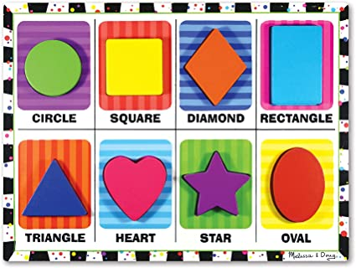](https://www.google.com/url?sa=i&url=https%3A%2F%2Fwww.amazon.com%2FMelissa-Doug-Preschool-Full-Color-Pictures%2Fdp%2FB000F676D8&psig=AOvVaw1XOyjxgF53ZCzYa2QUSrLb&ust=1587482527696000&source=images&cd=vfe&ved=0CAIQjRxqFwoTCICz6rOn9-gCFQAAAAAdAAAAABAD) 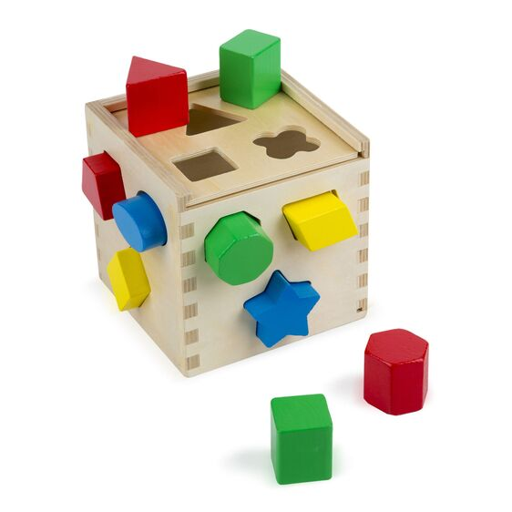 [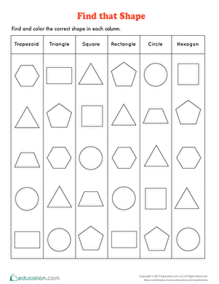](https://www.google.com/url?sa=i&url=https%3A%2F%2Fwww.education.com%2Fworksheet%2Farticle%2Ffind-that-shape%2F&psig=AOvVaw2d8NpX95UYVMl7GZtyX9kQ&ust=1587483436633000&source=images&cd=vfe&ved=0CAIQjRxqFwoTCKC7i-iq9-gCFQAAAAAdAAAAABAS)

|  |  |  |
| --- | --- | --- |
| **Single Word/Icon** | **Two-word/two-icon phrase** | **I want….** |
| Circle | Green circle | “I want” + circle |
| Square | Yellow square | “I want” + square |
| Diamond | Orange diamond | “I want” + diamond |
| Rectangle | Blue rectangle | “I want” + rectangle |
| Triangle | Blue triangle | “I want” + triangle |
| Heart | Pink heart | “I want” + heart |
| Star | Purple star | “I want” + star |
| Oval | Red oval | “I want” + oval |

[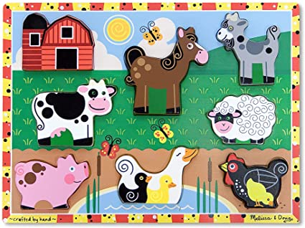](https://www.google.com/url?sa=i&url=https%3A%2F%2Fwww.amazon.com%2FMelissa-Doug-Preschool-Full-Color-Pictures%2Fdp%2FB000E9DPCW&psig=AOvVaw3TMN1KPG-OeWikaJsfYJZk&ust=1587482972043000&source=images&cd=vfe&ved=0CAIQjRxqFwoTCKD9jJCp9-gCFQAAAAAdAAAAABAE) [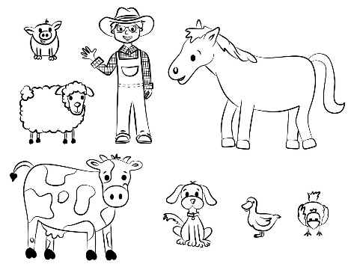](https://www.google.com/url?sa=i&url=https%3A%2F%2Fwww.pinterest.com%2Fpin%2F326511041716800575%2F&psig=AOvVaw1raPfkGT5DJjAUy3MiwiAu&ust=1587483378172000&source=images&cd=vfe&ved=0CAIQjRxqFwoTCOi6gc2q9-gCFQAAAAAdAAAAABAD)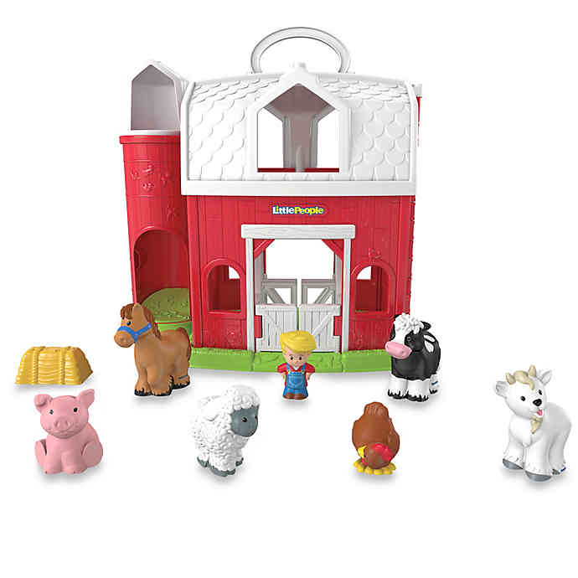

|  |  |  |
| --- | --- | --- |
| **Single Word/Icon** | **Two-word/two-icon phrase** | **I want….** |
| Cow | Black cow | “I want” + cow |
| Pig | Pink pig | “I want” + pig |
| Horse | Brown horse | “I want” + horse |
| Duck | White duck | “I want” + duck |
| Chicken | Black chicken | “I want” + chicken |
| Sheep | White sheep | “I want” + sheep |
| Horse | Gray goat | “I want” + goat |

Worksheet idea: circle or color the named animal. Circle or color the animal following animal noise (i.e., “Who says, “moo?!”)

[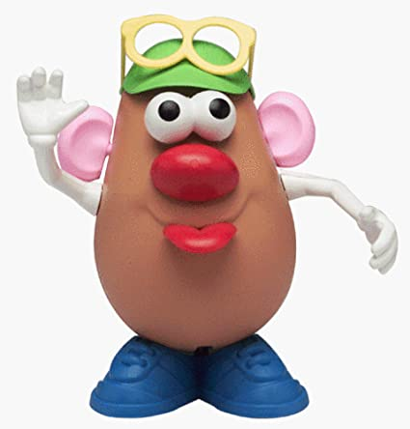](https://www.google.com/url?sa=i&url=https%3A%2F%2Fwww.amazon.com%2FPlayskool-2250-Mr-Potato-Head%2Fdp%2FB00000IW3G&psig=AOvVaw3up_R0kSxrLWG8YuBevCHO&ust=1587483518171000&source=images&cd=vfe&ved=0CAIQjRxqFwoTCLisxY2r9-gCFQAAAAAdAAAAABAH) [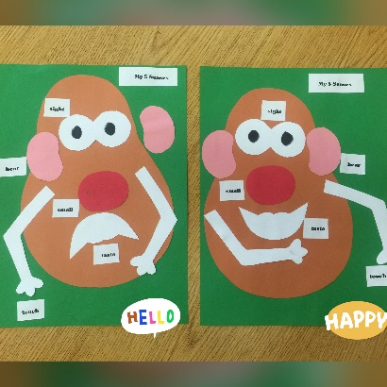](https://www.google.com/url?sa=i&url=https%3A%2F%2Fwww.pinterest.com%2Fpin%2F277886239484619330%2F&psig=AOvVaw2IzidRxoY3xwFLopUxQz9j&ust=1587483311341000&source=images&cd=vfe&ved=0CAIQjRxqFwoTCKDrsqyq9-gCFQAAAAAdAAAAABAD)

|  |  |  |
| --- | --- | --- |
| **Single Word/Icon** | **Two-word/two-icon phrase** | **I want….** |
| Eyes | Black eyes | “I want” + eyes |
| Nose | Red nose | “I want” + nose |
| Mouth | Red mouth | “I want” + mouth |
| Ears | Pink ears | “I want” + ears |
| Arms | White arms | “I want” + arms |
| Hat | Green hat | “I want” + hat |
| Glasses | Yellow glasses | “I want” + glasses |
|  |  |  |

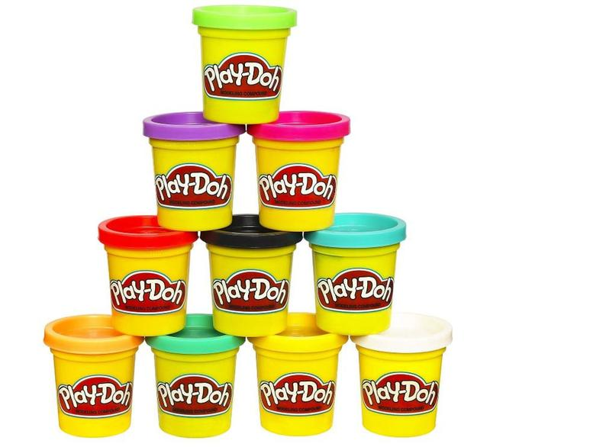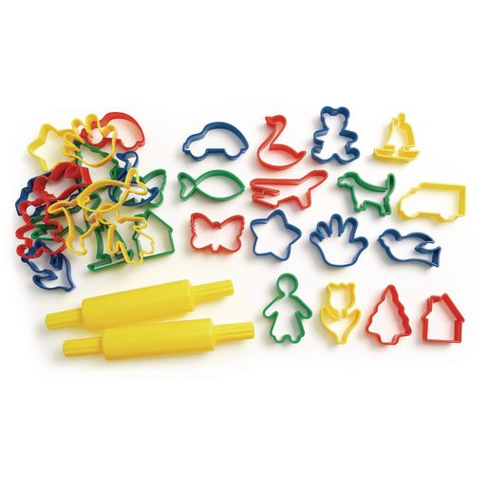

|  |  |  |
| --- | --- | --- |
| **Single Word/Icon** | **Two-word/two-icon phrase (after you’ve made a ball, snake or shape)** | **I want….** |
| Purple | Purple ball | “I want” + purple |
| Green | Green snake | “I want” + green |
| Pink | Pink car | “I want” + butterfly |
| Blue | Blue airplane | “I want” + star |
| Car | Yellow duck | “I want” + hand |
| Duck | Black truck | “I want” + red |
| Roller | White dog | “I want” + yellow |
| Airplane | Orange flower | “I want” + flower |

* To simplify this activity, stick to colors of the play-doh to request preferred color, “open” to request open…”more” (*don’t give all play-doh all at once* ) and “cookie cutter” for each cookie cutter shape

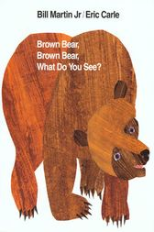 [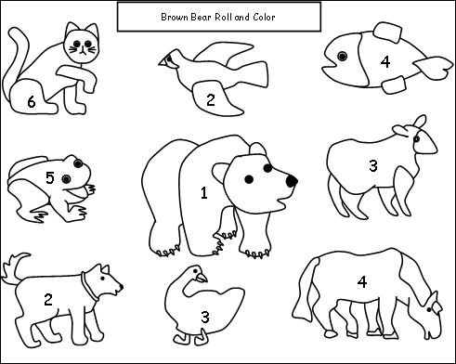](https://www.google.com/url?sa=i&url=https%3A%2F%2Flielaiskristaps.org%2F22-unique-gallery-of-brown-bear-coloring-sheet%2F&psig=AOvVaw0eSKYzYoyFkz3HeFwF2ps_&ust=1587486335590000&source=images&cd=vfe&ved=0CAIQjRxqFwoTCJD7oMy19-gCFQAAAAAdAAAAABAD) [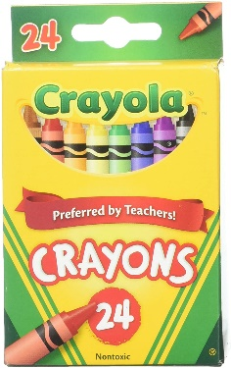](https://www.google.com/url?sa=i&url=https%3A%2F%2Fwww.amazon.com%2FCrayola-Crayons-Non-Toxic-Coloring-Supplies%2Fdp%2FB017MIRU96&psig=AOvVaw24-6ZnnHNX1veNFiqVEIIW&ust=1587486376616000&source=images&cd=vfe&ved=0CAIQjRxqFwoTCODj9N619-gCFQAAAAAdAAAAABAI)

|  |  |  |
| --- | --- | --- |
| **Single Word/Icon** | **Two-word/two-icon phrase** | **I want….** |
| **Identify animal on each page** | **Identify color and animal** | **Request crayons to color** |
| Bear | Brown bear | “I want” + brown |
| Horse | Blue horse | “I want” + blue |
| Cat | Purple cat | “I want” + purple |
|  |  |  |
|  |  |  |